Girls | 1 | 2 | 3 | 4 | 5 | 6 | 7
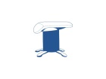  Vault | - Run, hurdle jump onto SB straddle jump to land still onto landed mat. | On red block with trampette, bounce up towards handstand/  flatback | Straddle through box (longways) | Squat through 3 sections of box. | Round off dismount off vault or red block. | Straight Jump onto red block, straight Jump off to land still. | Handstand Flat Back onto red block, without spot.
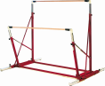  Bars | 2 X Chin-ups | 2 X Leg lifts | Chin Back circle without support | 3 x Swings on highbar with Regrasp | Climb from low bar and catch high bar with support | 3 x casts in a row without support on low bar | Swing-half turn dismount off high bar to land still
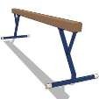  Beam | Forward roll on high beam to land without spot | Handstand to land on low beam without spot | Cartwheel to land on low beam without spot | Full spin on middle beam to land without spot | Cat leap on high beam | Round off dismount off high beam without spot | Handspring dismount off high beam with support
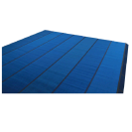  Floor | Bridge kick over | One handed cartwheel | Handstand hold for 3 seconds | 1.5 turn jump to land still | Backward roll to front support shape | Full spin | Arabesque held for 5 seconds
Boys | 1 | 2 | 3 | 4 | 5 | 6 | 7
VAULT | Handstand flat back onto red block from trampette | Squat through on 3 sections of box top | Straddle through on 3 sections of box top | Run, straddle jump from board to landing mat | Handstand flat back on red block | Run, jump straight jump onto red block, walk to end straight jump off | Handspring over red block from trampette with support
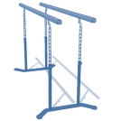  P-BARS | 10 seconds tuck planche above P.bars | 5 seconds half lever above P.bars | 5 x Dips | 5 x Upper arm swings with support | 5 x swings with support | 5 x swings without support | Upper arm roll between 2 red blocks
FLOOR | Handstand hold for 3 seconds into forward roll | Forward roll to straddle stand | Backward roll to front support | Cartwheel | Cartwheel into handstand forward roll to stand | Arabesque for 5 seconds | 5 seconds tuck planche on floor
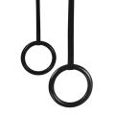  RINGS | 3 x chin ups | Chin up into basket hang | Basket hang lower through back lever to invert. | Tuck planche in support 10 seconds | Half lever 5 seconds | Half lever drop back into basket hang | Muscle up with support into 5 seconds tuck planche.

